**SWARM DOCKER DOKUMENTÁCIÓ**

* manager:192.168.28.111
* worker1:192.168.28.110
* worker2:192.168.28.108

***Mikrotik router alap beállításai:***

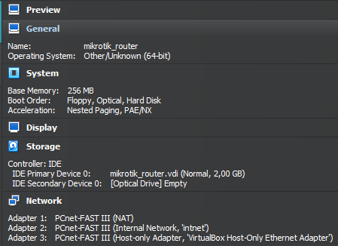

***Mikrotik router configurálás:***

ip/dhcp-client/add disabled=no interface=ether1

ip/address/add interface=ether2 address=192.168.28.1/24

ip/address/add interface=ether3 address=192.168.56.99

ip/firewall/nat/add chain=srcnat action=masquerade out-interface=ether1

ip/firewall/nat/add chain=dstnat action=dst-nat in-interface=ether3 dst-port=2222 to-address=192.168.28.111 to-ports=22 protocol=tcp

ip/firewall/nat/add chain=dstnat action=dst-nat in-interface=ether3 dst-port=2223 to-address=192.168.28.110 to-ports=22 protocol=tcp

ip/firewall/nat/add chain=dstnat action=dst-nat in-interface=ether3 dst-port=2224 to-address=192.168.28.108 to-ports=22 protocol=tcp

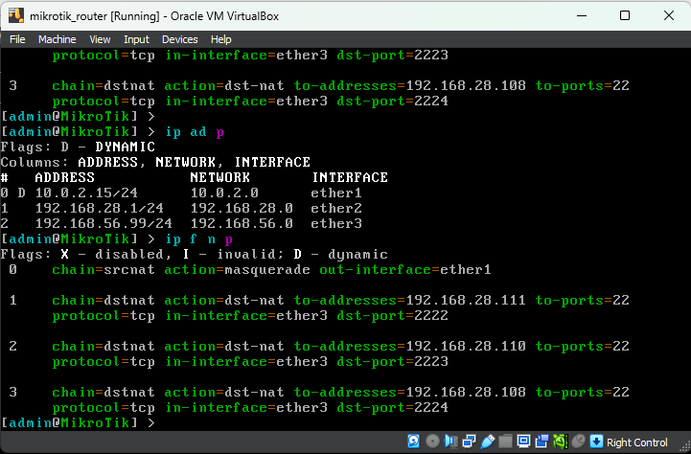

**DOCKER (MANAGER):**

***Gépnév beállítása:***

nano /etc/hosts

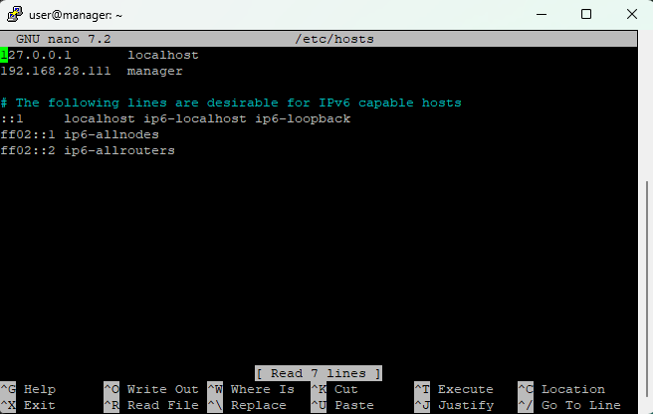

***IP beállítása:***

nano /etc/network/interfaces

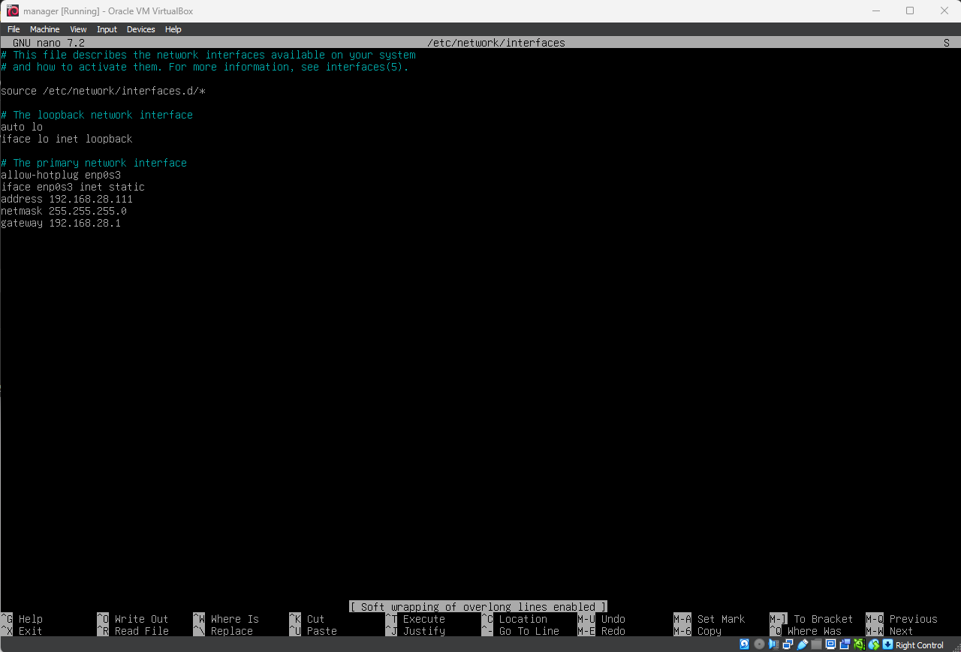

***Docker telepítése:***

Kapcsolódjunk rá Putty-val (IP: 192.168.56.99 | port: 2222)

apt install sudo

# Add Docker's official GPG key:

sudo apt-get update

sudo apt-get install ca-certificates curl

sudo install -m 0755 -d /etc/apt/keyrings

sudo curl -fsSL https://download.docker.com/linux/debian/gpg -o /etc/apt/keyrings/docker.asc

sudo chmod a+r /etc/apt/keyrings/docker.asc

# Add the repository to Apt sources:

echo \

"deb [arch=$(dpkg --print-architecture) signed-by=/etc/apt/keyrings/docker.asc] https://download.docker.com/linux/debian \

$(. /etc/os-release && echo "$VERSION_CODENAME") stable" | \

sudo tee /etc/apt/sources.list.d/docker.list > /dev/null

sudo apt-get update

***Manager gép:***

docker swarm init –advertise-addr 192.168.28.111

sudo apt-get install docker-ce docker-ce-cli containerd.io docker-buildx-plugin docker-compose-plugin -y

docker service scale web_app=5

docker service create \

--name=viz \

--publish=8080:8080/tcp \

--constraint=node.role==manager \

--mount=type=bind,src=/var/run/docker.sock,dst=/var/run/docker.sock \

dockersamples/visualizer

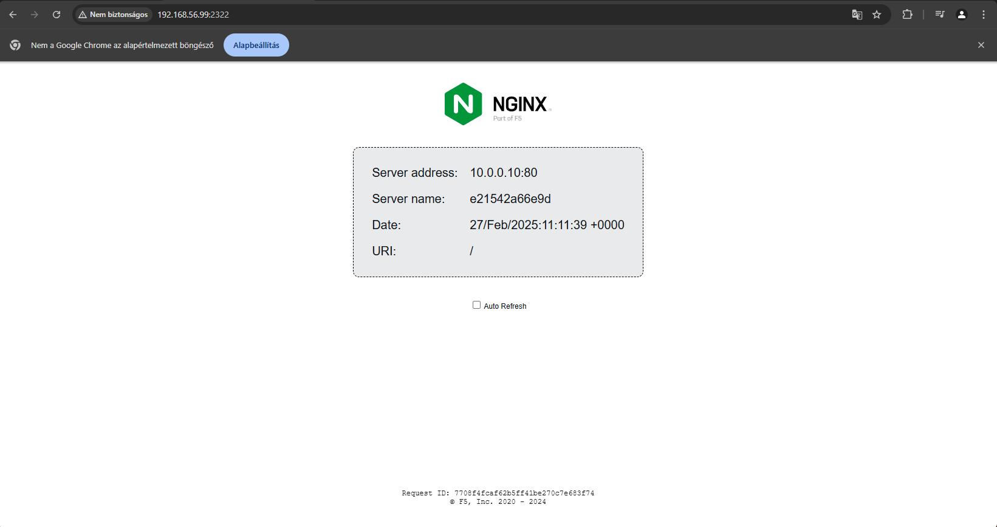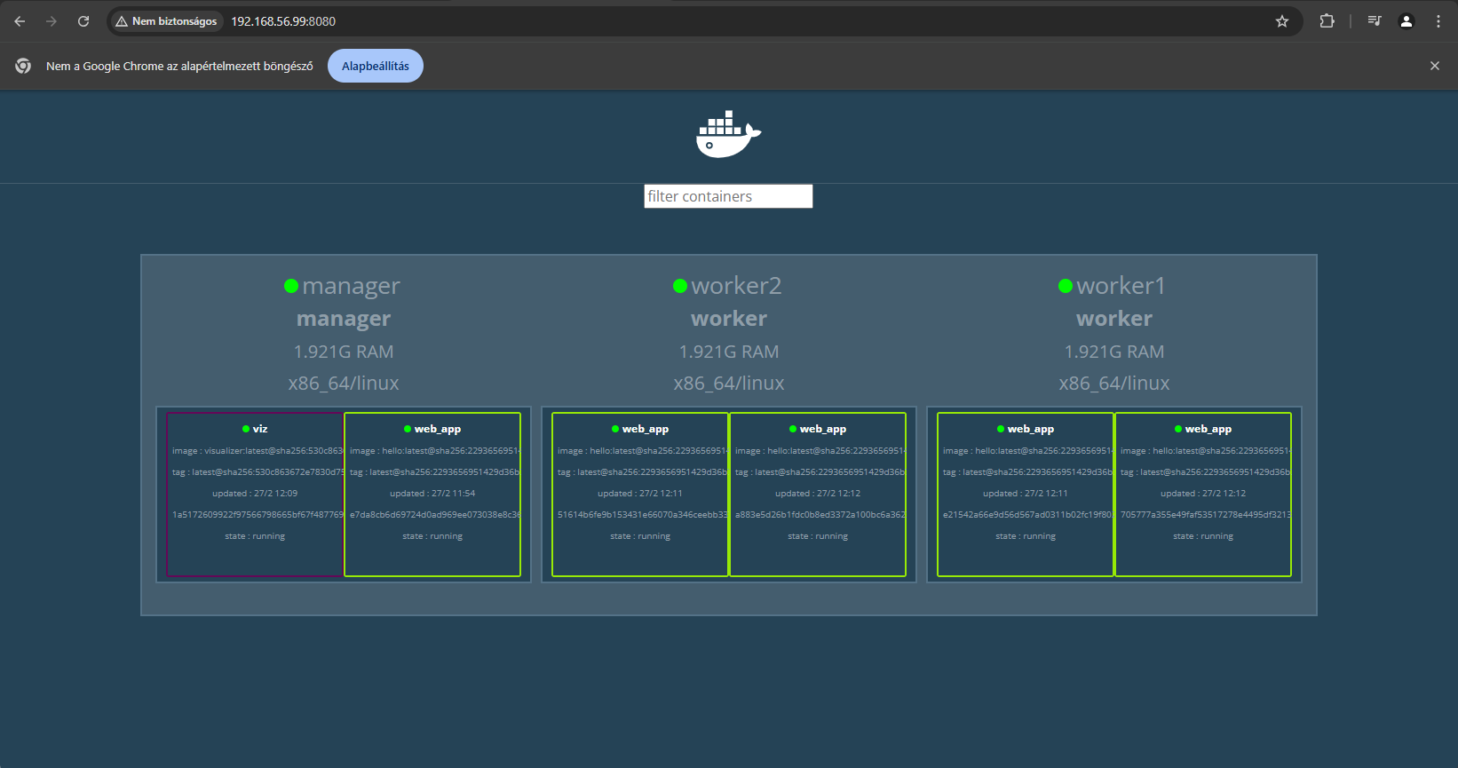

***Worker1 gép:***

docker swarm join --token "a Manager gépben"

***Gépnév beállítása:***

nano /etc/hosts

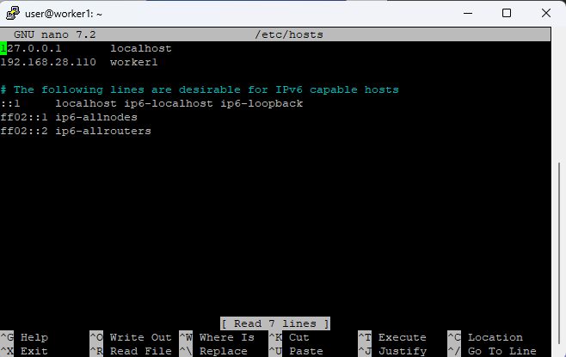

***IP beállítása:***

nano /etc/network/interfaces

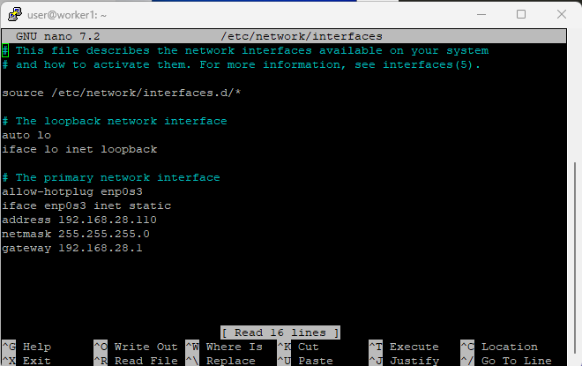

***Worker2 gép:***

docker swarm join --token "a Manager gépben"

***Gépnév beállítása:***

nano /etc/hosts

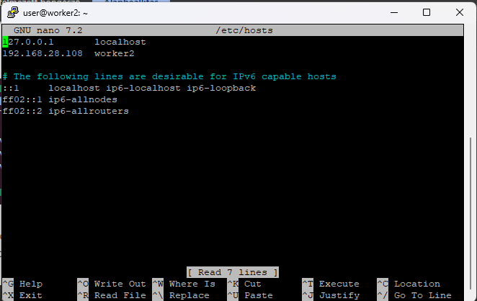

***IP beállítása:***

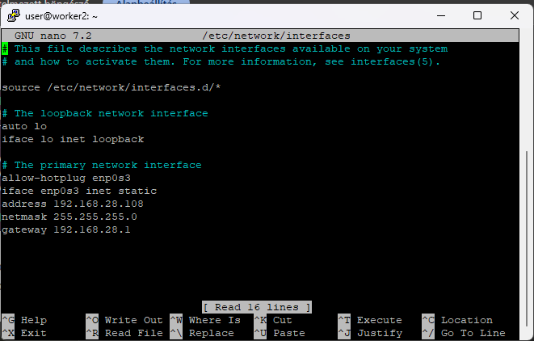nano /etc/network/interfaces